# CS 255 System Design Document Template

This template lays out all the different sections that you need to complete for Project Two. Each section has guidance to prompt your thinking. You will need to continually reference the interview transcript as you work to make sure that you are addressing your client’s needs. There is no required length for the final document. Instead the goal is to complete each section based on what your client’s needs are. Remove this note when you are finished, and replace all bracketed text with the relevant information.

## UML Diagrams

### UML Use Case Diagram

*[In Module Six, you were asked to complete a use case diagram based on your system design. If you would like to make any adjustments to your diagram, please do so. Please insert your use case diagram here. Check to make sure that you included appropriate components and symbols and that your design meets the client’s needs.]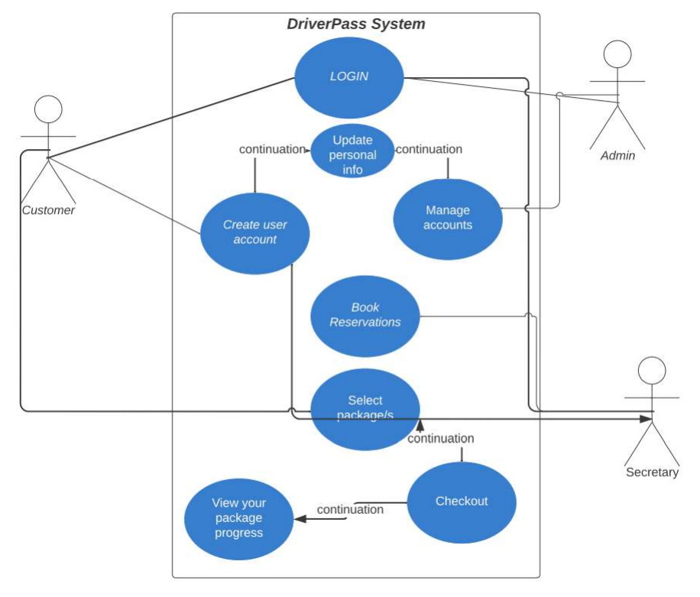*

### UML Activity Diagrams

*[You were asked to choose* ***two*** *use cases and create* ***two*** *activity diagrams, one for each use case. Please insert* ***both*** *of your activity diagrams here. Check to make sure that you included appropriate components and symbols and that your design meets the client’s needs.]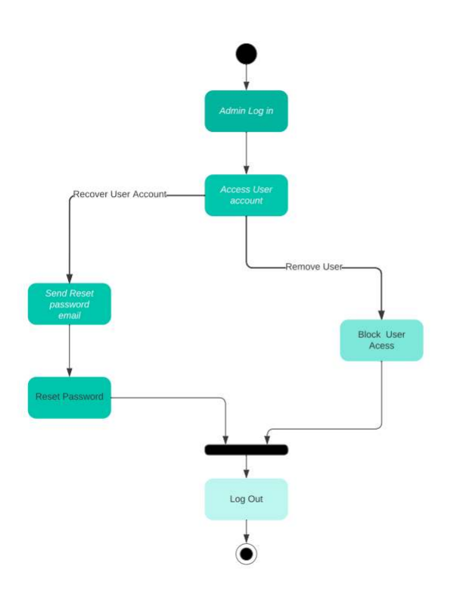*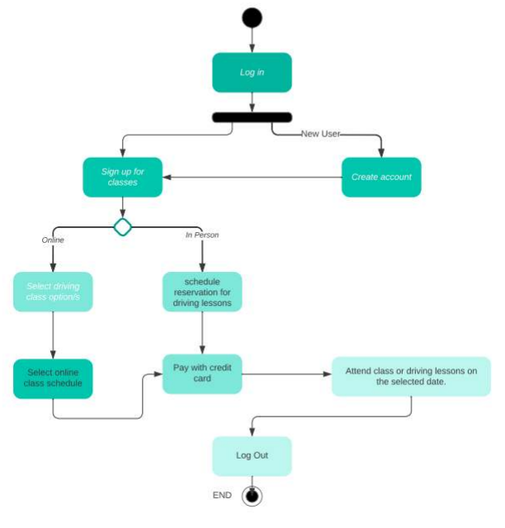

### UML Sequence Diagram

*[You were asked to create a sequence diagram based on* ***one*** *of the use cases you chose. Please insert your sequence diagram here. Check to make sure that you included appropriate components and symbols and that your design meets the client’s needs.]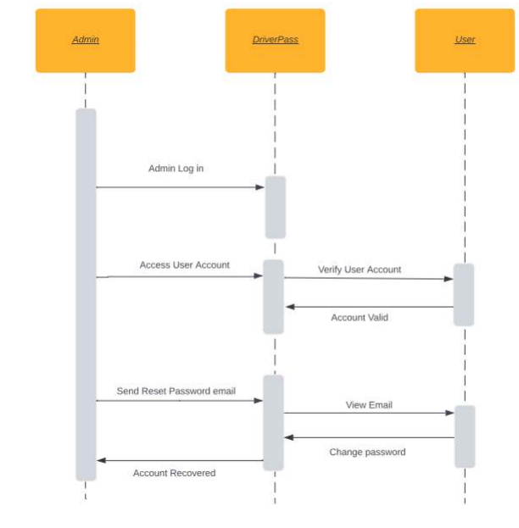*

### UML Class Diagram

*[You were asked to create a class diagram based on the different classes and attributes needed for your system design. You are* ***not*** *required to include methods, but you may if you wish. Please insert your class diagram here. Check to make sure that you included appropriate components and symbols and that your design meets the client’s requirements.]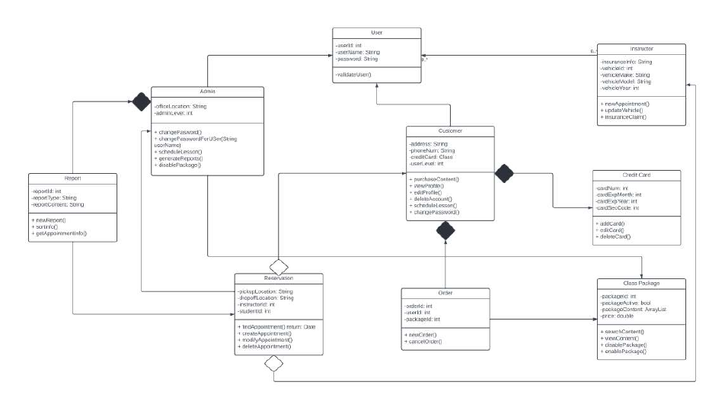*

## Technical Requirements

Hardware specifications for the host include:

-At least one physical server

-Networking cables A monitor, keyboard, and mouse for interaction

-Power sources

-Internet service provider

Hardware specifications for the client include

-a desktop or laptop computer

- an Ethernet cable or WiFi router

- power supplies

-Provider of Internet

Software requirements for the host include

-Windows Server operating system

-DriverPass software

-Docker software to manage VM traffic

-Security tools to prevent hackers from accessing critical data.

Software Requirements for Client:

-Web browser application (Firefox, Chrome, etc.)

-Operating system (Mac, Linux, Windows, etc.)

-Security software for protecting sensitive information

Tools Required for Development:

-Computers with programming software (Visual Studio, Eclipse, etc.)

-Internet connection for server upload

-Network admin tools for monitoring for suspicious traffic

Infrastructure Required:

-Server location or cloud provider